PREREQUISITES

|  |  |
| --- | --- |
| Date | 07 NOV 2022 |
| Team ID | PNT2022TMID07561 |
| Project name | Personal assistance for senior who are self-reliant |

IBM CLOUD SERVICES

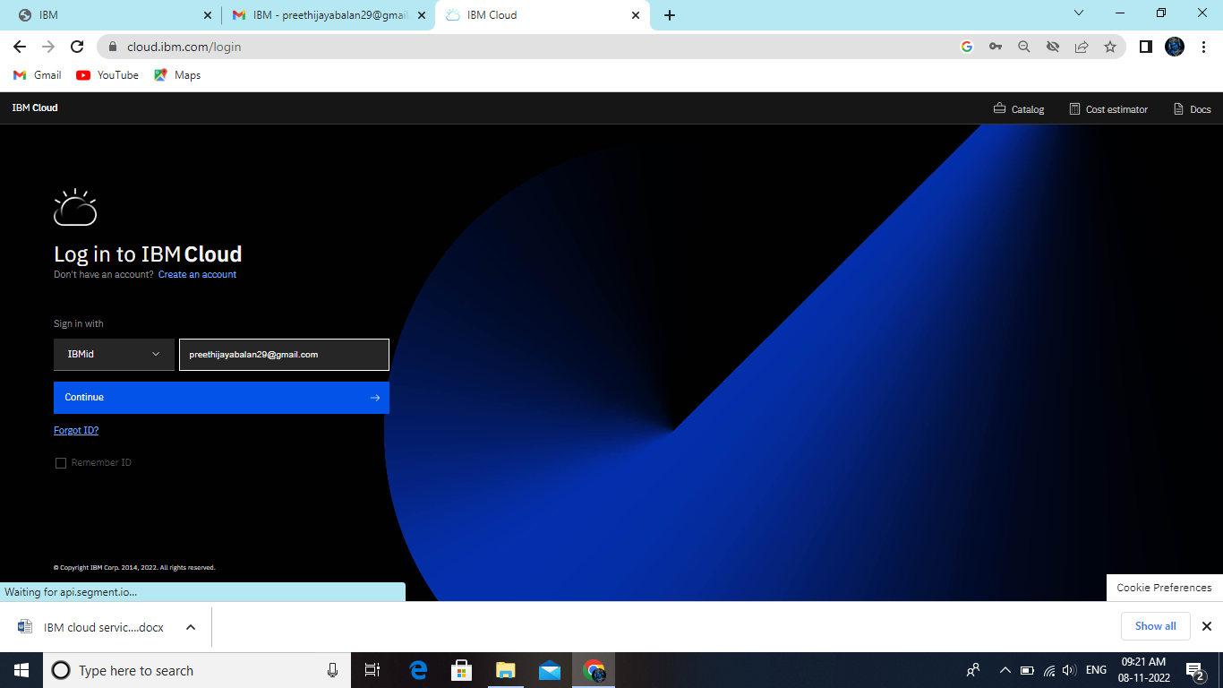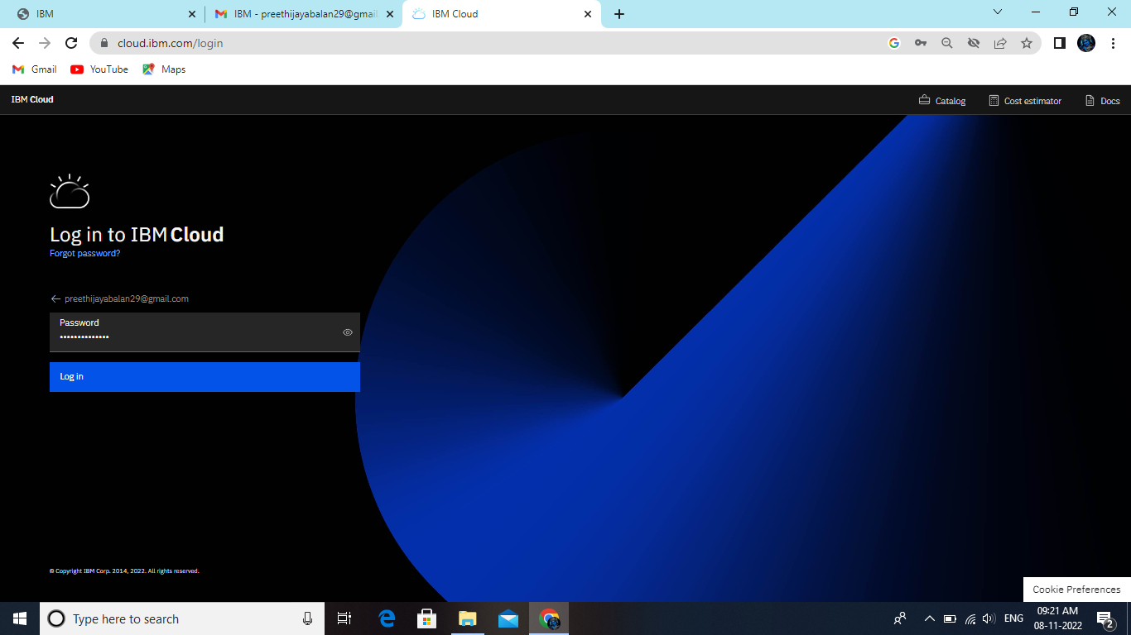

Dashboard

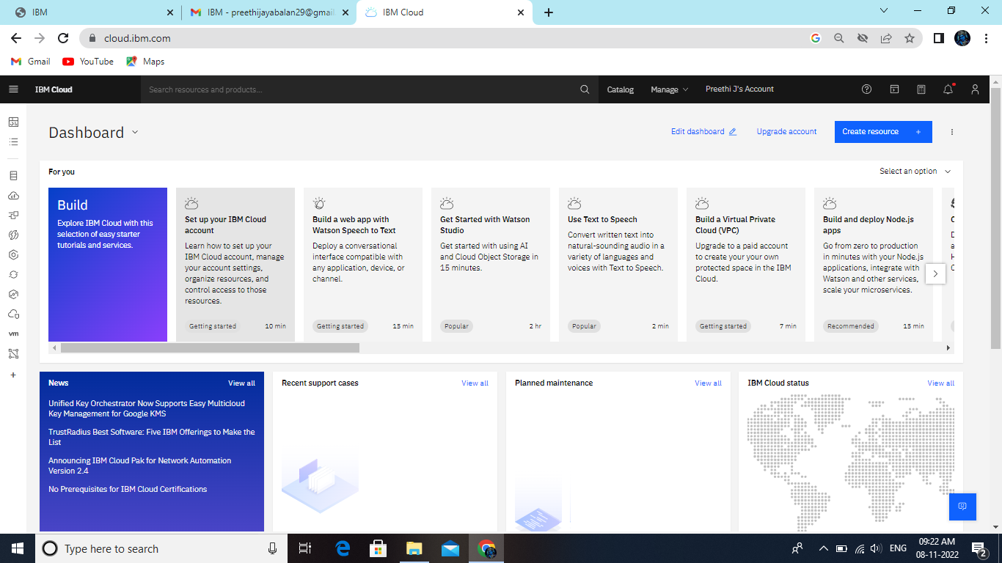

Account Settings

Smart Farmer-IOT Enabled smart

Farming application

Project Name

IBM Cloud services

